**AI Project:**

***Product Recommendation System Uniform cost search using Uninformed Search***

**Motivation:**

This system automatically recommends us products to the users on amazon using Item-based system, product popularity-based system, model-based system. With this system it will be easier for the users and creates a better shopping experience.

**Data:**

**Source:** <https://nijianmo.github.io/amazon/index.html>

**Content:** The data comes from Amazon Review Data. It was extracted in 2018 and it contains 200,953 records about different electronics.

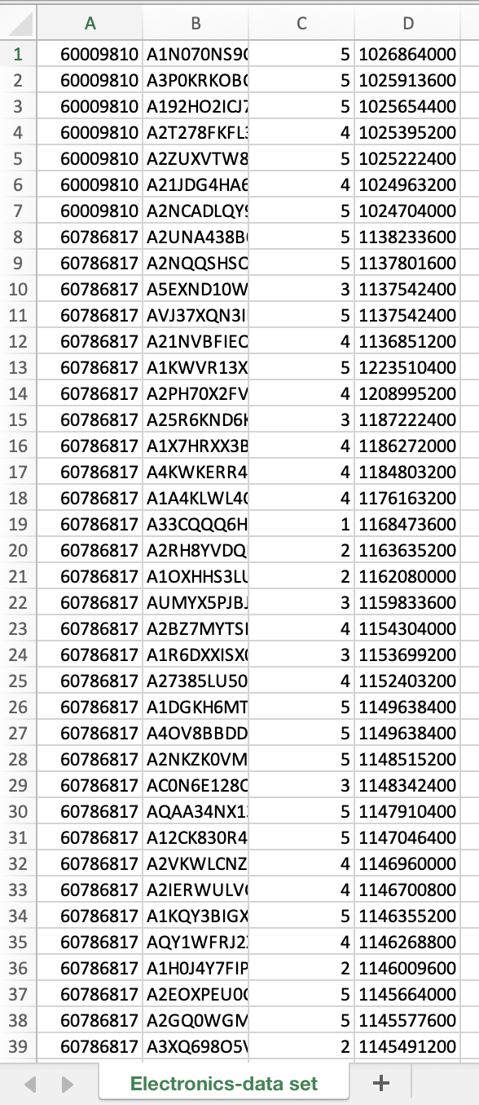

**Objective:**

The main objective of the project is to recommend products based on the user experience, by using Item-based system, product popularity-based system, model-based system also a graph is made after the scatter plot which helps the admin.

* Electronics (Product Recommendation System)
* Better/Smother shopping experience

**Implementation:**

**Import libraries:**

import matplotlib  
from IPython.core.interactiveshell import InteractiveShell  
from jedi.api.refactoring import inline  
  
InteractiveShell.ast_node_interactivity = "all"  
from numpy import count_nonzero, diag, arange, dot  
import pandas as pd  
import seaborn as sns  
from sklearn.model_selection import train_test_split  
from scipy.sparse.linalg import svds  
import warnings

**Imports:**

# Import the dataset and give the column names  
columns = ['userId', 'productId', 'ratings', 'timestamp']  
electronics_df = pd.read_csv('Electronics-data set.csv', names=columns)  
electronics_df.head()  
electronics_df.drop('timestamp', axis=1, inplace=True)  
electronics_df.info()

**Functions:**

def recommend(user_id):  
 user_recommendations = popularity_recommendations  
  
 # Add user_id column for which the recommendations are being generated  
 user_recommendations['userId'] = user_id  
  
 # Bring user_id column to the front  
 cols = user_recommendations.columns.tolist()  
 cols = cols[-1:] + cols[:-1]  
 user_recommendations = user_recommendations[cols]  
  
 return user_recommendations

def recommend_items(userID, pivot_df, preds_df, num_recommendations):  
 # index starts at 0  
 user_idx = userID - 1  
 # Get and sort the user's ratings  
 sorted_user_ratings = pivot_df.iloc[user_idx].sort_values(ascending=False)  
 # sorted_user_ratings  
 sorted_user_predictions = preds_df.iloc[user_idx].sort_values(ascending=False)  
 # sorted_user_predictions  
 temp = pd.concat([sorted_user_ratings, sorted_user_predictions], axis=1)  
 temp.index.name = 'Recommended Items'  
 temp.columns = ['user_ratings', 'user_predictions']  
 temp = temp.loc[temp.user_ratings == 0]  
 temp = temp.sort_values('user_predictions', ascending=False)  
 print('\nBelow are the recommended items for user(user_id = {}):\n'.format(userID))  
 print(temp.head(num_recommendations))

**Run(Output):**

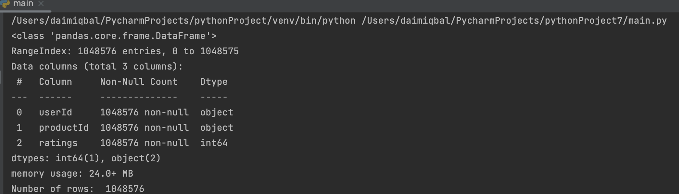

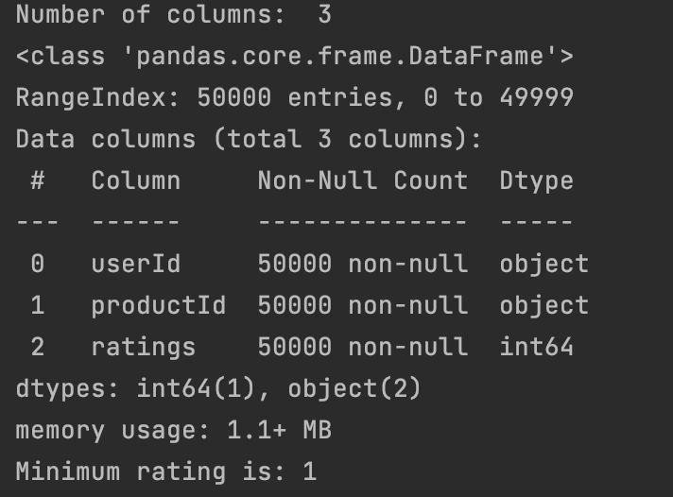

**Scatter plot:**

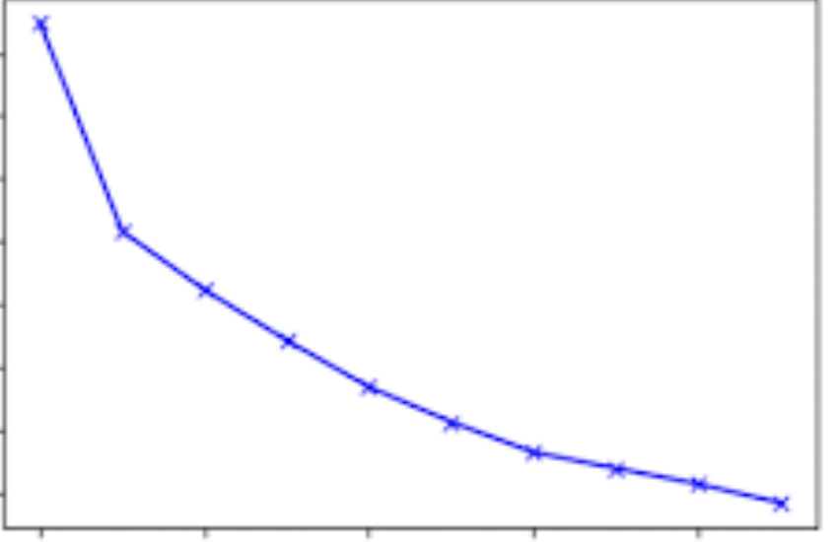

**Code:**

**Based on rating recommendation:**

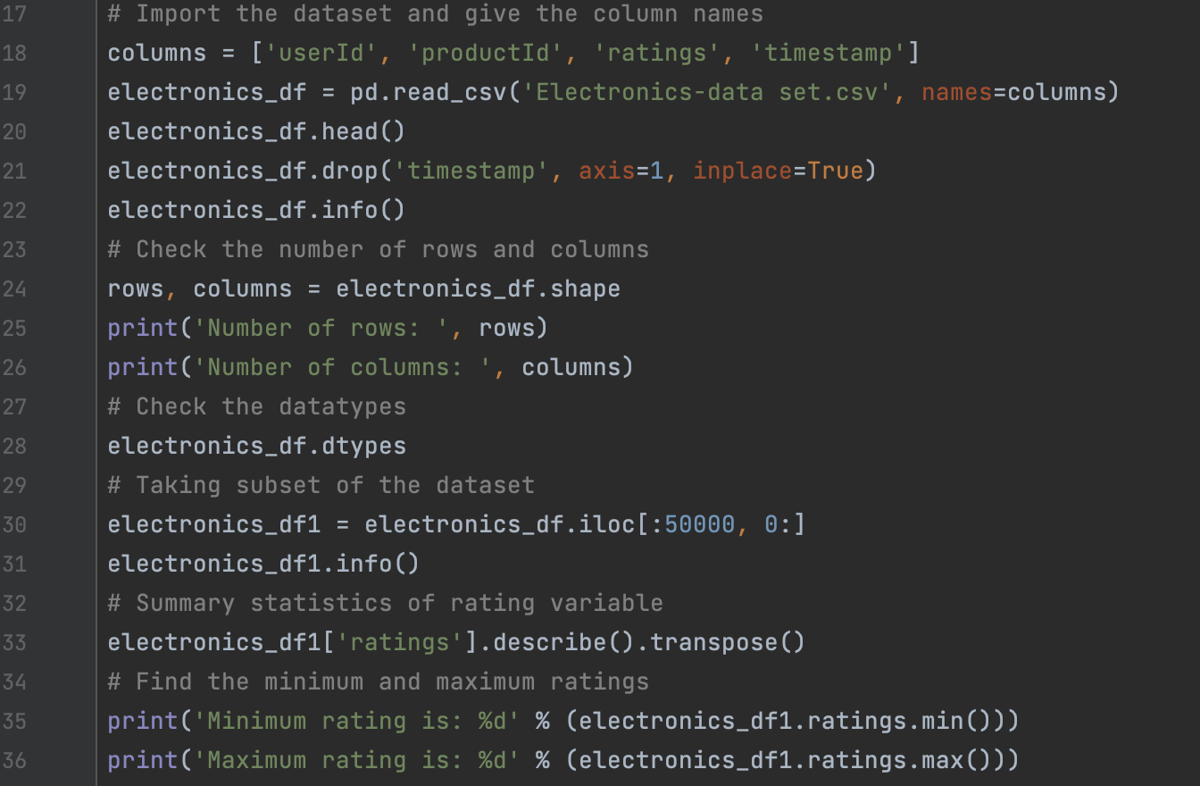

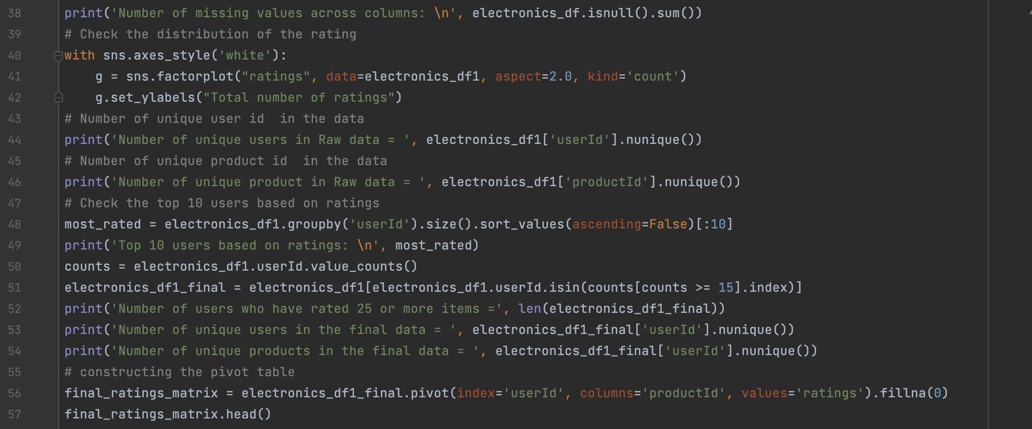

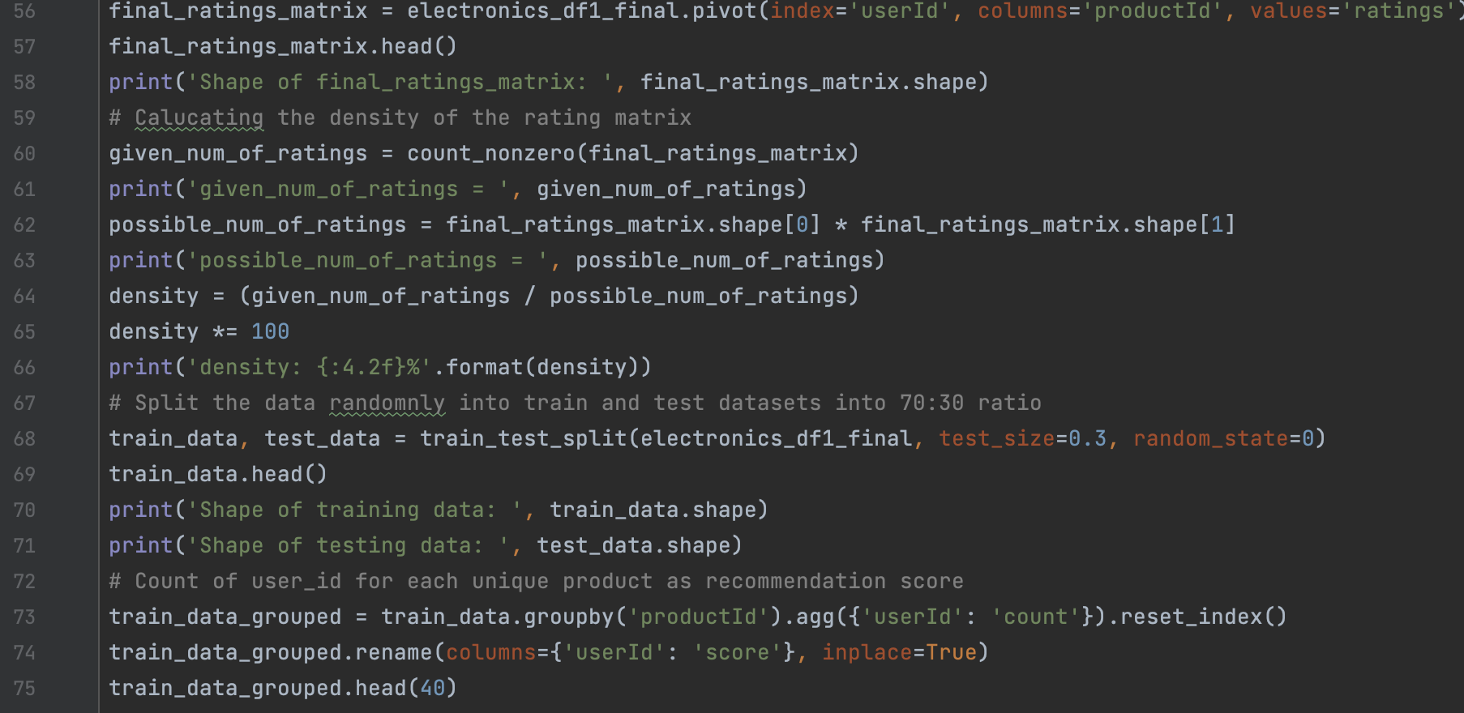

**Decomposition:**

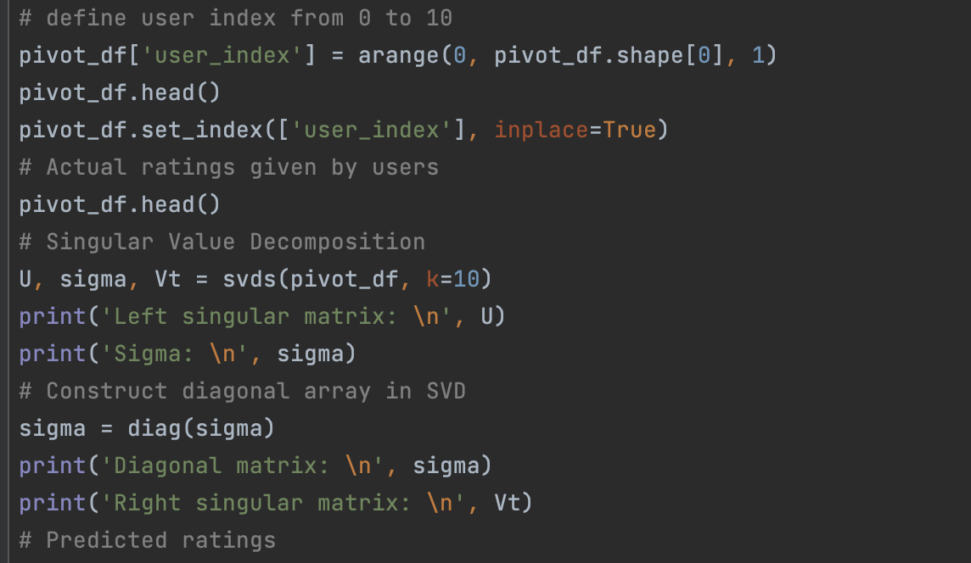

**Average Predicted:**

